Lab2 - Sample Shellcode Development Lab
In my previous classes when using Virtual Machines I always installed the base ISO’s then added programs ass needed. When we used Kali, their website already had ISO’s made so I just installed those. This is the actual first time I’ve installed using a .vdi file. On the first install I received an error while trying to log in with the user I created. The system would allow me to log in, but when it tried to associate my account with an online account the screen would close and log me back out.
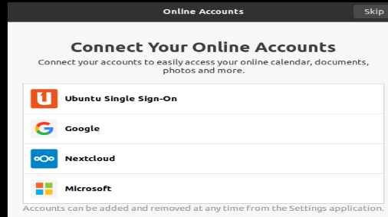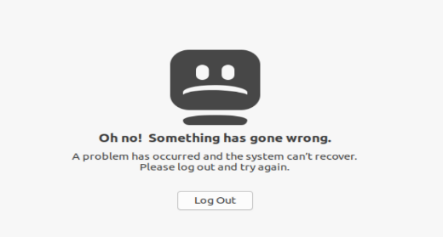

After trying various methods to circumvent the account linking I deleted the VM and reinstalled. The second install went well. A username was created with first initial + last name.
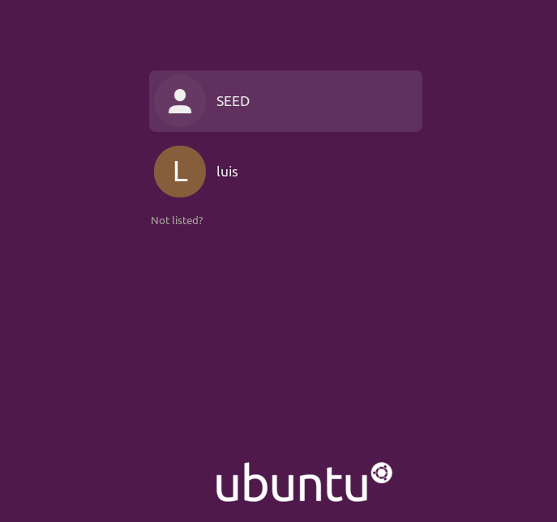

Task 01: Writing the Assembly Code

Shellcode Development Lab
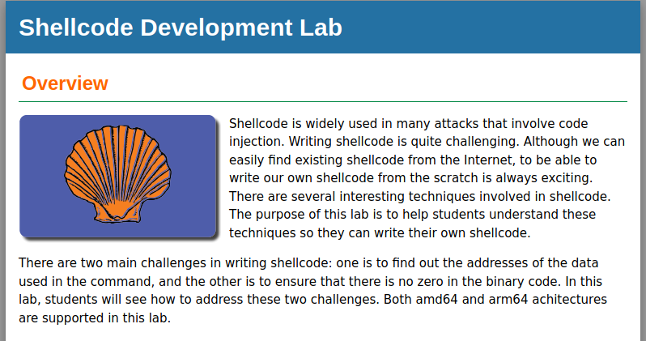
The labsetup.zip file has been downloaded and extracted into a folder on the VM. 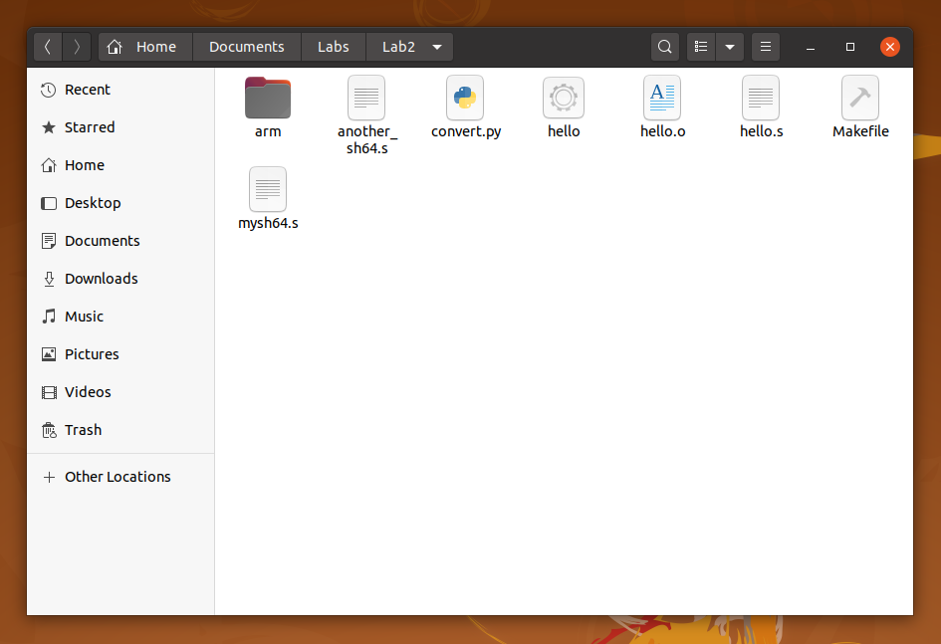

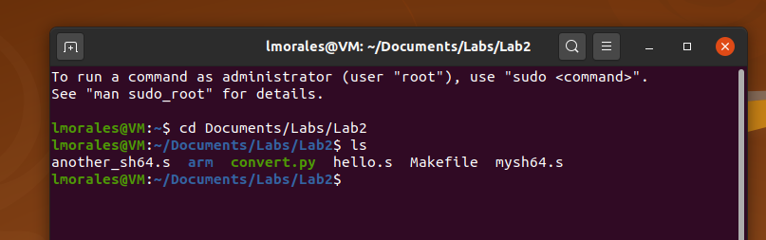
Once the lab files are extracted I navigated to them and edit using nano. After editing and compiling hello.o it was ran and “Hello, World” was displayed.
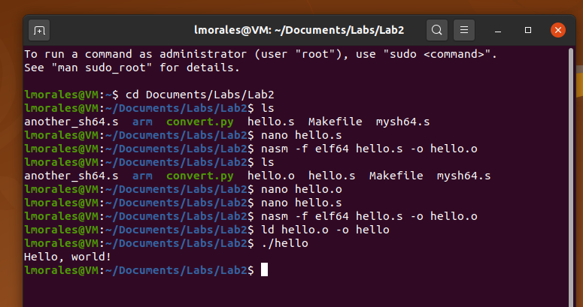
After displaying “Hello World” we dumped the file to see the assembly code using objdump
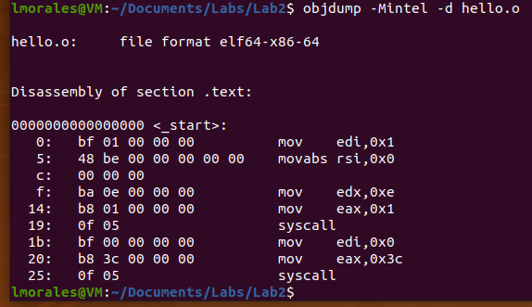
The lab also had me take a look at the machine code from the file
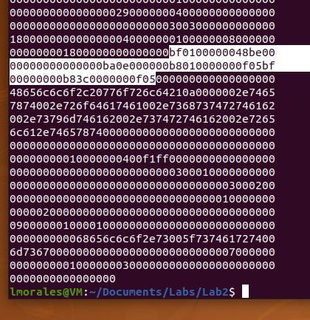

Using convert.py, the machine code is read and formatted into a python string. The script generates an array that stores the shellcode bytes.
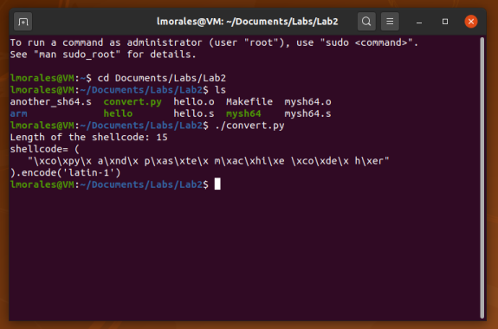

Task 02: Writing Shellcode
Task 2a: Understand the Code
We will be working with a provided file, mysh64.s
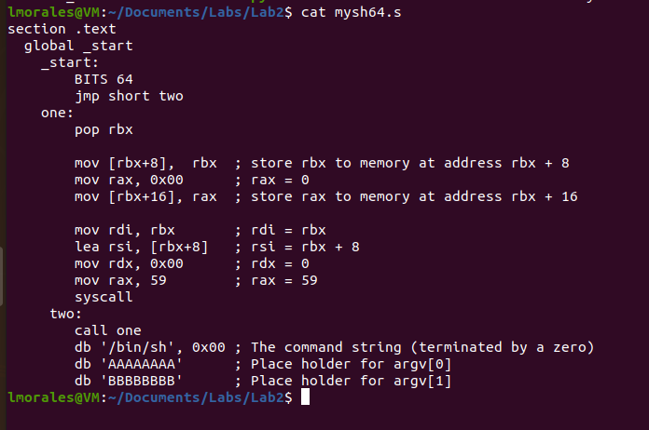

I compiled and linked the code using –omagic with the linker. This allows the executable to be writable.

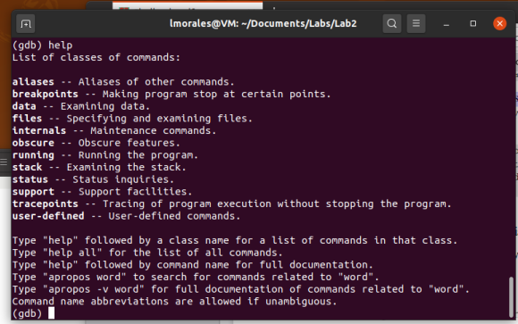

Here we wanted to execute a command to print “hello” and list files in a directory:
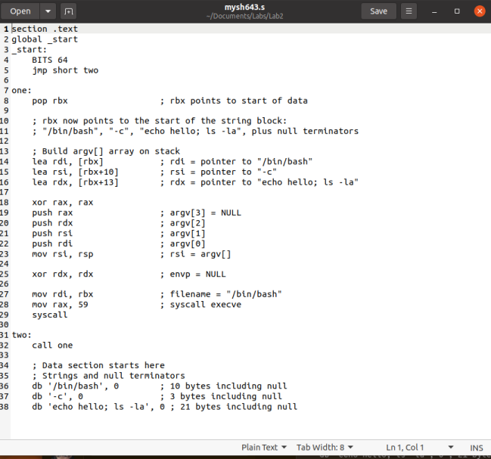
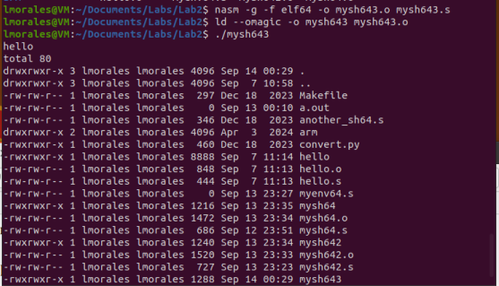
Task 03:
The lab asks us to use the Here we wanted to execute the "xxd-p-c20mysh.o" command and to copy and paste the machine code part to the convert.py file

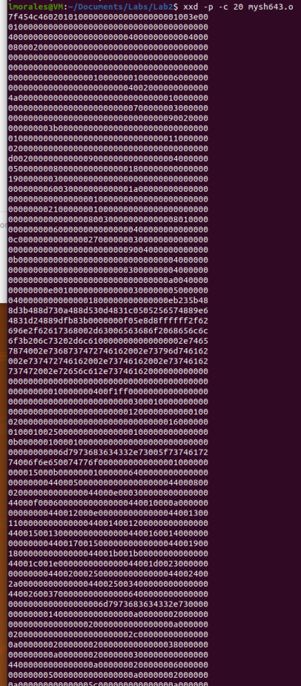
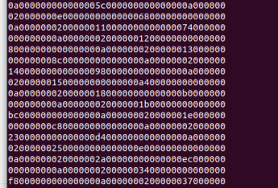

The convert.py which was included in the lab files is shown here:
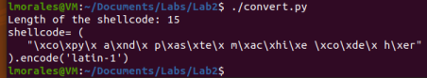
Once the convert.py file had been updated with the attack code here were the results:
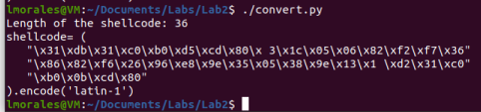

This lab had me learning many things from the set and use of a virtual machine using a .vdi file, to creating a user on a linux system. Once the actual lab started I was walked through doing more firsts while I have compiled files before I have not really worked with machine code and seeing our own code inserted into a file was eye opening.

